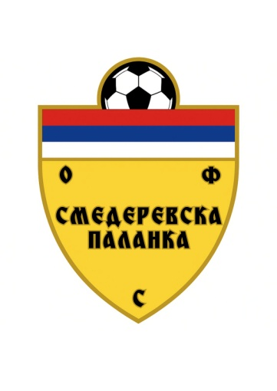
ADRESAR SLUŽBENIH LICA JASENIČKE OPŠTINSKE FUDBALSKE LIGE ZA TAKMIČARSKU 2026/2027.
S U D I J E
Jordan Kuzmanović | 062 9739368 | jordankuzmanovic99@gmail.com
Nemanja Tošić | 065 5060890 | nemanja2tosic03@gmail.com
Aleksandar Tomić | 067 7066044 | cira2508@gmail.com
Nikola Stevanović | 064 9543504 | stevanovicnikola68@gmail.com
Stefan Kočić | 066 9643218 | kocicstefan42@gmail.com
Bojan Marković | 061 3010501 | markovicbojan18@gmail.com
Andrija Mihajlović | 061 2965136 | mihajlovicandrija40@gmail.com
Aleksandra Radojević | 061 3107295 | radojevicaleksandra847@gmail.com
Vasilije Radojević | 061 6483939 | radojevicvasilije154@gmail.com
Mlađan Popović | 063 8618114 | mladjaa155@gmail.com
Nemanja Tomić | 066 302819 | tomic94nemanja@gmail.com
Marko Majstorović | 069 699290 | markomajstorovic86@gmail.com
Rodoljub Tošić | 063 7421287 | rodjatosic.1976@gmail.com
Dejan Grujić | 060 3190170 | grujicdejan943@gmail.com
Darko Panić | 060 4348269 | darkopanic6@gmail.com
Filip Jovanović | 063 7047981 | fjovanovic865@gmail.com
Momčilo Stojanović | 061 1578873 | momcilostojanovic660@gmail.com
Kristijan Tacković | 0621003448 | kica98tackovic@gmail.com
Lazar Pantić | 064 3123634 | panticlazar24@gmail.com
Ognjen Milić | 0616023545 | ognjenogi507@gmail.com
Filip Gromović | 065 5295977 | filipgromovic000@gmail.com
Mladen Palić | 065 2741155 | mladenpalic2@gmail.com
Dušan Gavrilović | 0601448303 | gavrilovicdusan46@gmail.com
D E L E G A T I

Slobodan Marković | 064 6640748 | zabarac71@gmail.com
Todor Kotlajić | 066 9728550 | ivajan73@gmail.com
Nenad Radojević | 065 6735550 | nessa81sd@gmail.com
Zlatan Radojević | 064 3234101 | zlatanradojevic1983@gmail.com
Stefan Prokić | 064 4294288 | prokastefan@gmail.com
Željko Đokić | 063629688 | zdjokic1@yahoo.com
Nenad Vasić | 064 2174519 | dzeravasic@gmail.com
Nikola Stojadinović | 060 0319061 | nikolaplazma77@gmail.com
Stefan Tošić | 064 1852573 | tosicstefan86@gmail.com
Milan Grujić | 064 1928771
Nebojša Milenković | 0652593803 | nebamilenkovic69@gmail.com

